DEERWALK INSTITUTE OF TECHNOLOGY
Tribhuvan University
Faculties of Computer Science

Bachelor of Science in Computer Science and Information
Technology
(BSc. CSIT)
Course: Statistics-II (STA-215)
Class of 2027/Semester: III
A Lab Report On:
Hypothesis Testing
Submitted to:
Er Prakash Amatya
Faculty, Department of Computer Science
Submitted by:
Name: Shaurav Bhandari
Roll No: 1333

- A sample of size 150 provided the mean of 47.5. Can it be regarded as representative of population with mean 50 and standard deviation 12 at 5% level of significance. Also find the 95% confidence limits for the population mean using the sample data.
Null Hypothesis; 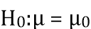, i.e, there is no significant difference between sample mean and population mean.
against
Alternative Hypotheses; 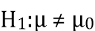, i.e., there is significant difference between sample mean and population mean.
Under null hypotheses, the test statistic is:
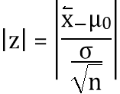
import scipy.stats as stats
import math
sample_size = 150
sample_mean = 47.5
population_mean = 50
population_std = 12
alpha = 0.05
se = population_std / math.sqrt(sample_size)
z_score = (sample_mean - population_mean) / se
p_value = 2 * (1 - stats.norm.cdf(abs(z_score)))
z_critical = stats.norm.ppf(1 - alpha / 2)
print("Decision:")
if abs(z_score) <= z_critical:
print("The sample mean can be regarded as representative of the population mean at the 5% level of significance.")
else:
print("The sample mean cannot be regarded as representative of the population mean at the 5% level of significance.")
confidence_interval = (
sample_mean - z_critical * se,
sample_mean + z_critical * se
)
print(f"Z-score: {z_score}")
print(f"P-value: {p_value}")
print("Confidence Interval:")
for i in confidence_interval:
print(i)
Output for first practical.
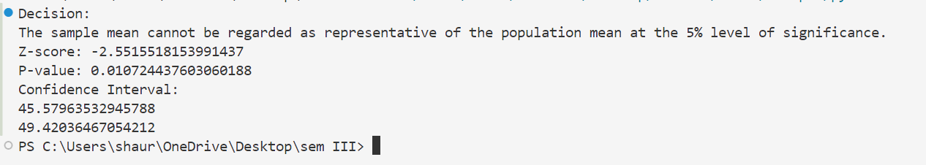
- Two samples of size 30 each is selected. From two independent populations with variances 840 and 920 respectively. Are the selected samples Have Equal means at 5% level of significance. Also find 95% confidence limits for the difference of means.
Null Hypothesis; 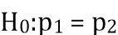, i.e, The proportions of smokers in the two populations are equal.
against
Alternative Hypothesis; 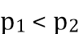, i.e., The proportion of smokers in population 1 is less than the proportion of smokers in population 2.
Under null hypothesis, the test statistic is:
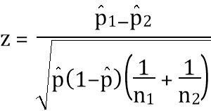
import scipy.stats as stats
import math
n1 = 30
n2 = 30
var1 = 840
var2 = 920
mean1 = 0
mean2 = 0
alpha = 0.05
se = math.sqrt(var1 / n1 + var2 / n2)
z_score = (mean1 - mean2) / se
p_value = 2 * (1 - stats.norm.cdf(abs(z_score)))
z_critical = stats.norm.ppf(1 - alpha / 2)
ci_lower = (mean1 - mean2) - z_critical * se
ci_upper = (mean1 - mean2) + z_critical * se
print(f"Test statistic (z-score): {z_score}")
print(f"P-value: {p_value}")
if p_value < alpha:
print("The samples do not have equal means at the 5% level of significance.")
else:
print("The samples have equal means at the 5% level of significance.")
print(f"95% Confidence Interval for the difference of means: ({ci_lower}, {ci_upper})")
Output for second practical.
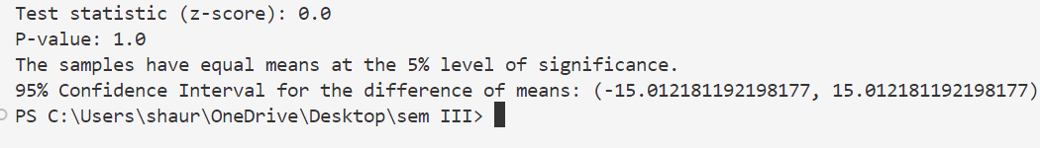
- A sample of size trout is selected from the population, which mean 1100. And standard deviation 275. Following are the records of the sample selected. Can the sample be regarded as the representative of parent population.
Null Hypothesis; 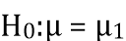, i.e, there is no significant difference between sample mean and population mean.
against
Alternative Hypothesis; 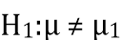, i.e., there is significant difference between sample mean and population mean.
Under null hypothesis, the test statistic is:
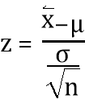
import numpy as np
import scipy.stats as stats
population_mean = 1100
population_std = 275
sample_data = [
852, 927, 902, 1149, 1576, 872, 1177, 1071, 895, 1155, 868, 1083,
897, 1700, 1398, 996, 1220, 1602, 891, 1088, 1301, 905, 1059, 1069,
1319, 1073, 1639, 1386, 1607, 1485
]
sample_size = len(sample_data)
sample_mean = np.mean(sample_data)
z_stat = (sample_mean - population_mean) / (population_std / np.sqrt(sample_size))
p_value = 2 * (1 - stats.norm.cdf(abs(z_stat)))
print(f"Sample Mean: {sample_mean}")
print(f"Test Statistic (z): {z_stat}")
print(f"P-value: {p_value}")
alpha = 0.05
if p_value < alpha:
print("Reject the null hypothesis: The sample is not representative of the population.")
else:
print("Fail to reject the null hypothesis: The sample can be regarded as representative of the population.")
Output for third practical.
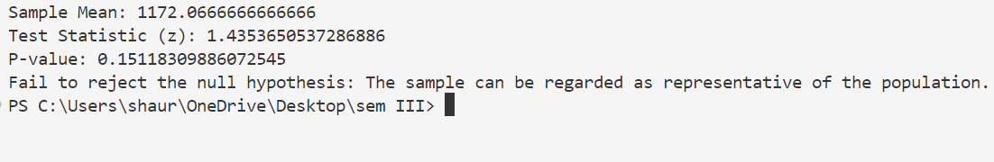

- Two samples of size 50 each are selected to test the proportion of the smokers among the proportion. It is observed that 44% in the first population and 50% in the second samples are smokers. Is the hypothesis of lesser smokers in first population is significant. Also find the 95
Null Hypothesis; 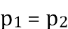, i.e., there is no significant difference between the proportions of smokers of the two samples.
against
Alternative Hypothesis; , i.e., the proportion of smokers in the first population is less than the proportion of smokers in the second population.
Under null hypothesis, the test statistic is:
import scipy.stats as stats
import math
n1, n2 = 50, 50
p1, p2 = 0.44, 0.50
x1, x2 = p1 * n1, p2 * n2
alpha = 0.05
P = (x1 + x2) / (n1 + n2)
se = math.sqrt(P * (1 - P) * (1/n1 + 1/n2))
z_stat = (p1 - p2) / se
p_value = stats.norm.cdf(z_stat)
z_critical = stats.norm.ppf(1 - alpha/2)
ci_lower = (p1 - p2) - z_critical * math.sqrt((p1 * (1 - p1) / n1) + (p2 * (1 - p2) / n2))
ci_upper = (p1 - p2) + z_critical * math.sqrt((p1 * (1 - p1) / n1) + (p2 * (1 - p2) / n2))
print(f"Test Statistic (z): {z_stat}")
print(f"P-value: {p_value}")
if p_value < alpha:
print("Reject the null hypothesis: The first population has significantly fewer smokers.")
else:
print("Fail to reject the null hypothesis: There is no significant difference in smokers.")
print(f"95% Confidence Interval for the difference of proportions: ({ci_lower:.4f}, {ci_upper:.4f})")
Output for fourth practical.
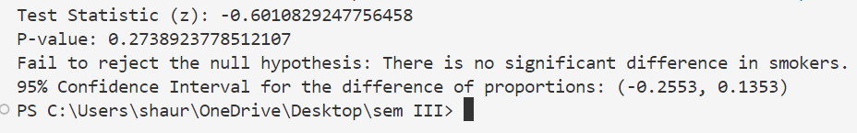
- The time (in minutes) spent by 10 randomly selected customers using internet in a cyber cafe are as follows;
- 35 ,20 ,30 ,45 ,60 ,40 ,65 ,40 ,25 ,50
- Can you say average time spent by customers is more than 30 minutes at 5% level of significance?
Null Hypothesis; 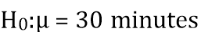, i.e., the average time spent by the customer is 30 minutes.
against
Alternative Hypothesis; 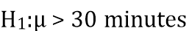, i.e., the average time spent by the customer is more than 30 minutes.
Under null hypothesis, the test statistic is:
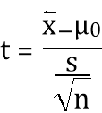
import numpy as np
from scipy.stats import ttest_1samp
data = np.array([35, 20, 30, 45, 60, 40, 65, 40, 25, 50])
population_mean = 30
t_stat, p_value = ttest_1samp(data, population_mean)
p_value_one_tailed = p_value / 2
print(f"T-statistic: {t_stat}")
print(f"P-value (one-tailed): {p_value_one_tailed}")
if (t_stat > 0) and (p_value_one_tailed < 0.05):
print("Reject the null hypothesis: The average time spent is more than 30 minutes.")
else:
print("Fail to reject the null hypothesis: The average time spent is not significantly more than 30 minutes.")
Output for fifth practical.
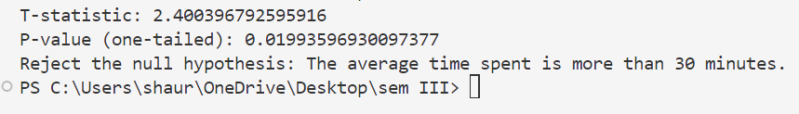

- Two kinds of manure were applied to sixteen one-hectare plot, other condition remaining the same. The yields in quintals are given below:
Manure I | 18 | 20 | 36 | 50 | 49 | 36 | 34 | 49 | 41
Manure II | 29 | 28 | 26 | 35 | 30 | 44 | 46

- Is there any significant difference between the mean yields? Use 5% level of significance.
Null Hypothesis; 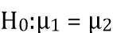, i.e., there is no significant difference between two sample means
against
Alternative Hypothesis; 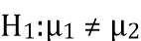, i.e., there is significant difference between the two sample means.
Under null hypothesis, the test statistic is:
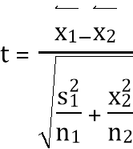
Degrees of freedom = 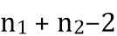
import numpy as np
from scipy.stats import ttest_ind
manure1 = np.array([18, 20, 36, 50, 49, 36, 34, 49, 41])
manure2 = np.array([29, 28, 26, 35, 30, 44, 46])
t_stat, p_value = ttest_ind(manure1, manure2, equal_var=True)
print(f"T-statistic: {t_stat}")
print(f"P-value: {p_value}")
print(f"Mean of manure 1: {manure1.mean()}")
print(f"Mean of manure 2: {manure2.mean()}")
print(f"Standard deviation of manure 1: {manure1.std()}")
print(f"Standard deviation of manure 2: {manure2.std()}")
if p_value < 0.05:
print("Reject the null hypothesis: There is a significant difference in yields between the two types of manure.")
else:
print("Fail to reject the null hypothesis: There is no significant difference in yields between the two types of manure.")
Output for sixth practical.
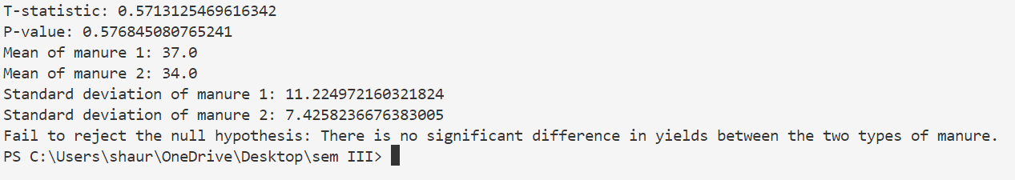
- Memory capacity of 10 students was tested before and after training, state whether the training was effective or not from the following scores; Roll No. 1 2 3 4 5 6 7 8 9 10 Before training 12 14 11 8 7 10 3 0 5 6 After training 15 16 10 7 5 12 10 2 3 8
Null Hypothesis; , i.e., there is no significant difference between two sample means
against
Alternative Hypothesis; , i.e., there is significant difference between the two sample means.
Under null hypothesis, the test statistic is:
Degrees of freedom =
import numpy as np
from scipy.stats import ttest_rel
before_training = np.array([12, 14, 11, 8, 7, 10, 3, 0, 5, 6])
after_training = np.array([15, 16, 10, 7, 5, 12, 10, 2, 3, 8])
t_stat, p_value = ttest_rel(before_training, after_training)
print(f"T-statistic: {t_stat}")
print(f"P-value: {p_value}")
level_of_significance = 0.05
if p_value <= level_of_significance:
print("Reject the null hypothesis: The training was effective.")
else:
print("Fail to reject the null hypothesis: The training was ineffective.")
Output for seven practical.
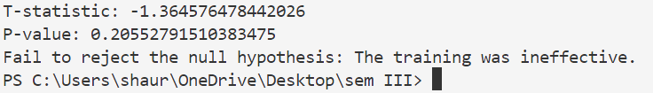

- Find confidence interval of mean assuming normal distribution for following data.
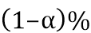 confidence limits for the popoulation mean are given by:
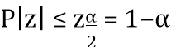
Evaluating this, we get
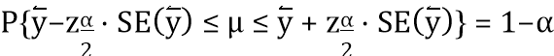
import scipy.stats as stats
import numpy as np
heights = [
78, 55, 68, 48, 65, 76, 57, 55, 65, 75, 51, 61,
68, 67, 76, 78, 71, 56, 57, 67, 58, 51, 50, 58,
50, 77, 55, 48, 70, 55, 58, 70, 56, 52, 74, 61,
69, 76, 61, 68, 78, 56, 78, 57, 66, 66, 74, 66,
48, 73, 71, 70, 62, 74, 76, 50, 69, 75, 65, 48
]
mean_height = np.mean(heights)
sem_height = stats.sem(heights)
confidence_level = 0.95
alpha = 1 - confidence_level
z_critical = stats.norm.ppf(1 - alpha / 2)
confidence_interval = (
mean_height - z_critical * sem_height,
mean_height + z_critical * sem_height
)
print(f"Mean height: {mean_height}")
print(f"95% Confidence Interval for the mean height:")
for i in confidence_interval:
print(i)
Output for eighth practical.
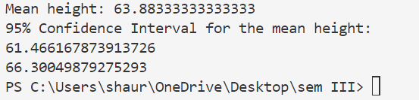

- Construct random data of size 5000 height of students categorized by gender. Considering minimum height of 120 cms. to 185 cms. a) Draw a sample of size by calculating appropriate sample size assuming the proportion of male and female are equal for 5 b) Test the hypothesis of male and female are of equal in proportion for the population you have constructed. c) d) e) Test the hypothesis of male are taller than female students at 5 If the sample size is 500 what will be the change in decision for above hypothesis. Find the 95 difference of height for both cases of sample.
import numpy as np
import pandas as pd
population_size = 5000
genders = np.random.choice(['Male', 'Female'], size = population_size)
heights = np.random.uniform(120, 185, size = population_size)
data = pd.DataFrame({
'Gender': genders,
'Height': heights
})
z = 1.96
p = 0.5
q = 1- p
d = 0.05
sample_size = int((z**2 * p * (1 - p)) / d**2)
sample = data.sample(n = sample_size)
from statsmodels.stats.proportion import proportions_ztest
number_of_males = sample['Gender'].value_counts()['Male']
number_of_females = sample['Gender'].value_counts()['Female']
total_sample = number_of_females + number_of_males
z_stat, p_value = proportions_ztest([number_of_males, number_of_females], [number_of_males, number_of_females])
from scipy.stats import ttest_ind
male_heights = sample[sample['Gender'] == 'Male']['Height']
female_heights = sample[sample['Gender'] == 'Female']['Height']
t_stat, p_value = ttest_ind(male_heights, female_heights)
print(f"T-statistic: {t_stat}")
print(f"p-value: {p_value}")
if p <= 0.05:
print("Reject the null hypothesis")
else:
print("Fail to reject the null hypothesis")
sample_500 = data.sample(n = 500)
male_heights_small = sample_500[sample_500['Gender'] == 'Male']['Height']
female_heights_small = sample_500[sample_500['Gender'] == 'Female']['Height']
t_stat, p_value = ttest_ind(male_heights, female_heights)
print(f"T-statistic: {t_stat}")
print(f"p-value: {p_value}")
if p <= 0.05:
print("Reject the null hypothesis")
else:
print("Fail to reject the null hypothesis")
from statsmodels.stats.proportion import proportion_confint
from statsmodels.stats.weightstats import DescrStatsW
number_of_males = sample['Gender'].value_counts()['Male']
number_of_females = sample['Gender'].value_counts()['Female']
ci_proportion = proportion_confint(number_of_males, number_of_females)
print(f"Confidence interval: {ci_proportion}")
male_count = sample['Gender'].value_counts()['Male']
ci_gender = proportion_confint(male_count, sample_size, alpha=0.05, method='normal')
print(f"95% Confidence Interval for Gender Proportion: {ci_gender}")
male_stats = DescrStatsW(male_heights)
female_stats = DescrStatsW(female_heights)
ci_diff = male_stats.tconfint_mean(alpha=0.05)
print(f"95% Confidence Interval for Male Height: {ci_diff}")
Output for ninth practical.
